Exceptions and Error Handling
Lecture 6
Instructor Notes

- The Exception Hierarchy
- What is an exception?
  - An exception indicates an unexpected error condition in a program.
  - Exception objects contain information about what went wrong.
- 4 Reasons exceptions are thrown
  - You make a programming error (Example: negative array index value)
  - Internal error in Java
  - You call a method that throws an exception
  - You throw an exception with throw
- Exception Keywords: try, throw, catch, throws, finally
- Kinds of exceptions:
  - Checked and unchecked
    - Checked exceptions must be caught and handled
    - Unchecked exceptions need not be caught and handled
      - You can't recover from them anyway
- RuntimeException
    - An unchecked exception indicating a programming error
      - Examples:
        - ClassCastException
        - ArrayIndexOutOfBoundsException
        - NullPointerException
      - Every subclass of the Runtime Exception represents an unchecked exception. All this really means is that you aren’t required to add a try-catch or throws to methods that may throw one.
- Error
    - An unchecked exception indicating an internal JVM error
      - Examples:
        - OutOfMemoryError
        - StackOverflowError
- Exception Hierarchy:
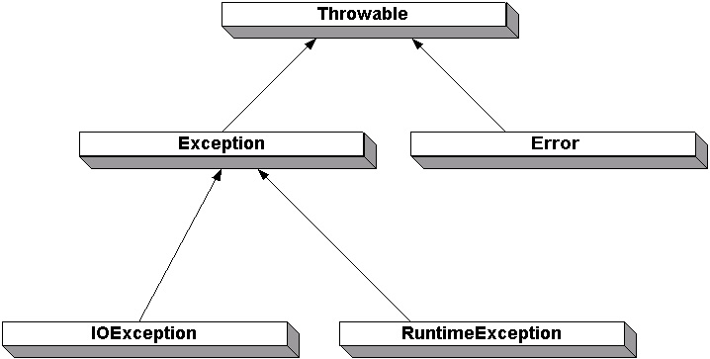
- Throwable (Base class for all exceptions)
    - Error
    - Exception
      - RuntimeException
      - (Other Exceptions)
- Catching Exceptions
  - Use a try/catch/finally to catch and handle exceptions
  - "Exception Handler" example:
  - try {
// code that can throw an exception
} catch ( SomeException ex ) {
// code that handles SomeException
} catch ( SomeOtherException ex1 ) {
} finally {
// code that is executed always, if an exception occurs or not
}
  - If an exception occurs:
    - Code within the try block, after the exception, is not executed
    - Code after the exception is not executed
    - Code in the finally block is ALWAYS executed
  - Catch the more specific (lower in the hierarchy) exceptions first
    - If you reverse the order, you'll never catch them
  - You can rethrow the exception to propagate it up the call chain
    - throw ex;
    - Useful for partially handling an exception
  - Typical code in a catch block:
System.out.println("Exception in classname.methodname(): " + ex);
ex.printStackTrace();
// clean up or recover from exception
    - Call ex.getMessage() to get the detailed message
  - Database example

- Exception Propagation and the throws Keyword
- Exception Specification
  - Format:
    - void methodName() throws SomeException, SomeOtherException {...}
  - Tells the compiler that the exception must be caught by the caller
    - Enforces exception handling
  - Allows the method to avoid handling an exception and to pass it to its caller
    - Consolidate error handling in one place
- When overriding a method, you can only remove exceptions from the list, not add them.
- The method may throw an exception of the class in the throws clause or any subclass (more specific)
- Exception Propagation
  - Exceptions will propagate up the call stack (through all methods with a "throws" clause) until it is caught.

- Throwing an Exception
- Throw the exception when you detect the error:
  - throw new SomeException();
  - throw new SomeException( "An Explanation" );
  - throw new SomeException( param, param, param, ... );
    - If you create your own exception, you can create a constructor that accepts addition information
- The class that throws the exception must have a throws clause

- Creating Custom Exceptions
- Create a class, extending from Exception or any subclass
- Provide a default constructor and a constructor that accepts a string
  - Call super( theString );
- You can capture more information about the exception by adding a constructor with more parameters

- Using Exceptions Properly
- Only use exceptions for unexpected errors
  - Why? High overhead, object created every time
  - Example: Don't use exceptions to check for EOF
- Consolidate exception handling in one try/catch block
  - Why? Cleaner code that separates normal processing from error processing
- Don't squelch exceptions
  - Why? Bugs could go undetected
  - Exception: InterruptedException on sleep()
  - Use e.printStackTrace() in your catch blocks to help with debugging
- Propagate exceptions where appropriate
  - Why? To handle exceptions at the best level
- Traditional Exception Handling
  - Traditional Exception Handling Example:
Within some class: public Boolean func() {
if(foo.bar()) {
// do something
if(obj.open() != -1)
// do something
else
return false; // error
}
  - Java-style Exception Handling – Enables transfer of control from where the error occurred to where it can be handled; via try, throw, and catch; clean way to check for errors w/o cluttering source
  - Java-style Exception Handling Example
Within some class: public void func() throws MyException {
try{
Foo.bar();
// do something
obj.open();
// do something
} catch (MyException e) {
// attempt to handle exception
}
}

